**Resume Writing**

**Topics:**

1. The Importance of Resume

2. Difference between CV and Resume

3. Things to include in resume

4. Format and Sample resume

**Objective:**

* Upon successful completion of this topic students will learn to write a resume showing their skills, experiences, and scholastics that they will use once applying for employment, a scholarship, or college.

**Introduction**

Many people think that the goal of resume building is to get more jobs. This is completely wrong. Your resume provides an overview of your experience, skills, abilities, and accomplishments Whether you have a paper or electronic version of your resume, your resume is a tool to sell yourself to your potential employers. If your continuation is done right, you will get the opportunity to appear for the next round of selection process. If you are planning for any such employment the first things which aspirants can do is make their resume done initially.

**Evolution**

* 1482 - Leonardo Da Vinci writes the first professional resume.
* Resumes were just formalities. Most wrote them on scraps of paper over lunch with employers.
* Resumes are like Facebook profiles. They include weight, age, height, marital status, and religion.
* Resumes are no longer just formalities; they are now expected. Resumes start to include outside interests like sports and hobbies. Word processors make resumes more professional.
* 2003 - LinkedIn is launched.
* 2006 - Video resumes pick up.

**What is Resume & its purpose?**

A resume (also spelled résumé) is an overview about who you are!

Resume is a French word which means summary. Resume is nothing but an overall summary of yourself. It’s a tool to advertise yourself. Here comes the point why it’s needed?

When an employer wants to hire an employee due to large competition in the market, he/she will be having so many options in front of him/her. In this busy schedule they cannot invest or waste their valuable time on examining each candidate who applied for the post. Therefore, to save their time & efforts employers are asking for resumes so they will get an idea how eligible you are for the job which they are offering to you.

So, therefore this is the best chance for the aspirants to create their first impression on the employer with the help of an attractive resume without visiting the employer at their place.

**1.**         **The Importance of resume building**

The Resume is a bridge between aspirants and their recruiter. Hence the importance of a resume cannot be neglected. Try to build a resume which will make you special than the rest of your competitors. So, it’s up to the aspirants how they make themselves remember their recruiter. Many people have this question: why is it so important to have a resume? Let’s figure out this:

* 1. **Resume is nothing but aspirant’s brief introduction.**

The resume speaks volumes about you as a professional. It means what you have done in the past. What are you doing right now and where are you heading? Just think of a piece of paper that talks a lot about you including the past, present, and future. Doesn't that sound amazing? But remember this story of the past, present and future needs to be addressed immediately, otherwise they will lose interest. Therefore, the task of telling a short story can be a little tricky. So, you may need help writing your resume professionally.

* 1. **Selling your skills.**

By continuing to write well, you can sell the skills you have accumulated over the years. You can let the employer know all the skills you have acquired through the various experiences and how you will use them to improve the organization. That's exactly what the employer needs to know nowadays. They want to know what your skills will be in the organization. And if your resume is successful in telling them so, the purpose is served.

* 1. **To showcase your creativity.**

It is very important to create your own product in this world of technology and this journey begins right after college and your studies. If you are entering a world of technology to work, it is important that from day one you have to fix things. To demonstrate your knowledge, your skills, your experience, your expertise, and your accomplishments, you need to have a good rewriting that can present you as a good professional or emerging professional who is ready to face this challenging world.

* 1. **You are sure of your work.**

It often happens that we plan and do something, until we succeed in our endeavours, but after a while, it can be a year or more, we tend to forget that. We recognize the challenges we face now and try to cope with them. So, if you start all over again, you will remember everything you did and accomplished in your professional career. It will happen if you continue to renew your resume every time you change jobs and join a new company, whenever you get a new role, a new project, a new team to manage. Write down where the company rewards you for your work. That doesn’t mean you’re making your resume, a daily diary, just paying attention to the important events ahead of you professionally. And you can always rearrange your progress and keep a master copy with you. And remember that the greatest author in the world of books needs the help of an editor. You can read it, read it again, check it ten times, but it is always good to take a second opinion.

**2.**         **Difference Between CV and Resume**

The full form of ‘CV’ is curriculum vitae. It’s a Latin word which means that ‘course of your life’ on the same page Resume is ‘summary’ which derived from the French word ‘résumé’.

A CV reflects the full history of your qualifications, so the length of the document varies. In contrast, a resume presents a brief overview of your abilities and qualifications for a certain position, so the length is shorter and defined by years of experience (usually 1-2 pages).

CVs are used by people looking for relationships, grants, post-office positions, and teaching/research positions in postsecondary institutions or senior research positions in the industry. Graduate school applications often request a CV, but usually require a resume that includes any publication and descriptions of research projects.

In many European countries, a CV is used to describe all job application documents, including a resume. In the United States and Canada, CV and resume are sometimes used interchangeably. If you are not sure which type of document you should submit, it is best to ask for clarification.

**Resume, CV, Portfolio & Biodata**

• **Curriculum Vitae**

-For an experienced candidate

-Detailed information on the person's experience

 • **Portfolio**

-For artists — will have visual records of their works

-Example: Models will carry photos and videos of their photo shoots and ramp walks

• **Biodata**

-Biological data — details on physicality and health

-Interviews where health and physicality are necessary.

-Example: Army interview, police selection

• **Resume**

-French word which means summary

-For a fresher Should not be more than or less than 2 pages

**3.**         **Things to include in resume**

This section of the resume is completely depending on the aspirant and their recruiter.

Here we listed some important section which aspirant should include in their resume

**3.1**   **Personal Information**:

As we all know our first identity is our name. Therefore, initially we need to mention our personal details in the resume.

Aspirants can mention:

* Name
* Email address
* Contact details
* Residential address

Example:

Top left

-Name

-Residential address below the name

Top middle

-Mobile number

-E-mail id below the mobile number

Top right

-Passport size photograph

**(There is no fixed format of resume)**

**3.2**   **Career objective**

Career objective is a line of statement or phrase which shows that a candidate is having a particular goal in his/her life.

It is not a must in a resume, but it will be helpful for the recruiter to understand candidates’ style and persona. It should be a phrase. Try to make it simple, crisp and to the point.

·       How to write career objectives?

It should be phrase which comprises of:

-        Aspirants position in organization

-        Aspirants profession

-        Modern technology

-        Challenges

Example: “To get a job as a junior programmer in an IT firm and gain as much as possible in the field. And, to apply what I gained when confronted by challenges”

**3.3**   **Scholastics (Academic details)**

This is the most important section of the resume. On the basis of this employer will decide if the aspirant has fulfilled their required educational criteria or not. Many people think that it is just a piece of cake to mention educational details in a resume. But while doing so we need to follow one standard format for the same.

Always write your educational details in reverse chronological order.

* Always start with your most recent qualification first.
* Aspirants need to include Name of the college/university, Degree you earned or working on it, passing year, Percentages (%, CGPA etc.)
* If possible, write this in table format.

**3.4**   **Technical skills/ computer skills**

This is also an important section of resume. You need to list down all your technical or computer skills in this section.

Now these skills are totally depending on the aspirant's background (Branch & field) as well as employer requirement.

Let’s take example:

**Core companies**

**1.**         **Mechanical Engineering:**

AutoCAD

ProE

Hypermesh

Ansys

**2.**         **Electronics & Telecommunication**

MATLAB

ORCAD

Embedded C

**IT COMPANIES:**

          C

          C++

          JAVA

          .NET

**Operating system known:**

        Wrong answers: windows 7 or 8, i-os

        Right answers: Red Hat linux, ubuntu 14.04

**3.5**   **Project details**

This section is very important for the technical background aspirants. Most probably companies do visit campuses in the last year so at that time aspirants can mention their project details on which they are working at the same time you can mention about your mini projects which is already done in previous semesters.

**Example:**

|  |  |  |  |  |
| --- | --- | --- | --- | --- |
| Sr.No | Project title | Technology used | Project duration | Description |
| 1 | **Automation of solar panel** | **Devices- PIC, Photovoltaic sensors, Solar panel**  **Programming language- Embedded C** | **6 months-from January 2014-june 2014** | **Tracking the sun and ensuring 90-degree incidence on the solar panel to generate maximum electricity.**  **Won best project award at techtonic 2014 at parul university.** |

**Note:**The areas in which the project was done should feature in “areas of    interest”.

**3.6**   **Achievements**

This is not a mandatory section. You can mention your district, state, or national level achievement in this section. field can be anything. You can also mention your college level achievement here, but it should be at least intra college level.

**3.7**   **Co-curricular activities**

* Includes paper presentations, seminars and any technical event like technical quiz
* Format: Presented the paper titled "paper title" at event name — college name on Date Month, Year.

Or

* Won the 1" or 2nd or 3'd prize or "The Best Project Award" for the project "paper title" at symposium name — college name on Date Month, Year.

Or

* Won the 1" or 2 or 3"1 prize for the event "event name" at symposium name — college name on Date Month, Year.

Or

* Attended the seminar "seminar name" on area conducted by person/organization at a place on Date Month, Year.

**3.8**   **Extra-curricular activities**

In this section you can include your following achievements:

* Singing, dancing or any art — certificates necessary
* Contributions through NGOs • Involvement in organizations
* Organizing events — certificates necessary

**3.9**   **Hobbies**

Kindly mention those hobbies which should contribute to a person's intellectual growth.

**Wrong examples:** Watching TV, Listening to Music, Tennis, chatting with friends, Browsing.

**Right examples:** Watching NEWS and Documentary Channels Listening to or Playing Western Classical Music or Carnatic Music or Hindustani Music, Singing, Dancing Following Tennis or Playing Tennis, Reading Novels, Gardening, Cooking.

**3.10 Personal Details**

•        **Year of birth**

•        **Sex**

•        **Nationality**

•        **Fathers name**

•        **Fathers occupation**

•        **Mothers name**

•        **Mothers occupation**

**4.**         **Format**

There is no fixed format for resume, but here we are mentioning some guidelines which can be beneficial for you while making a resume.

•        **Declaration is not needed.**

•        **You can use any font which is neat and formal (e.g. Calibri, Arial, Times new roman).**

•        **Font:**

**Name and Heading: 14**

**Others: 12**

**Sample Resume:**

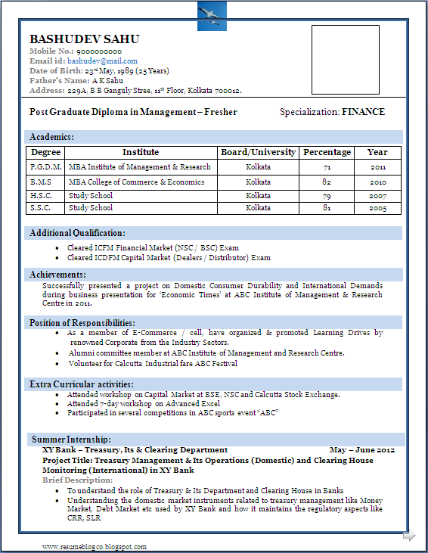

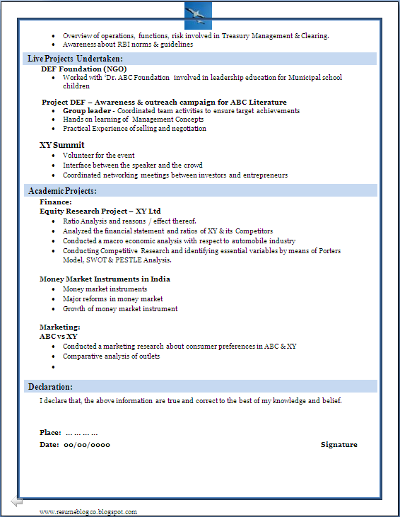

**References**

1. Sanjay Kumar, Pushpa Lata. Communication skills. Oxford higher education.
2. P. Subba Rao, B. Anita Kumar, C. Hima Bindu. Technical Communication Skill. CENGAGE Learning.